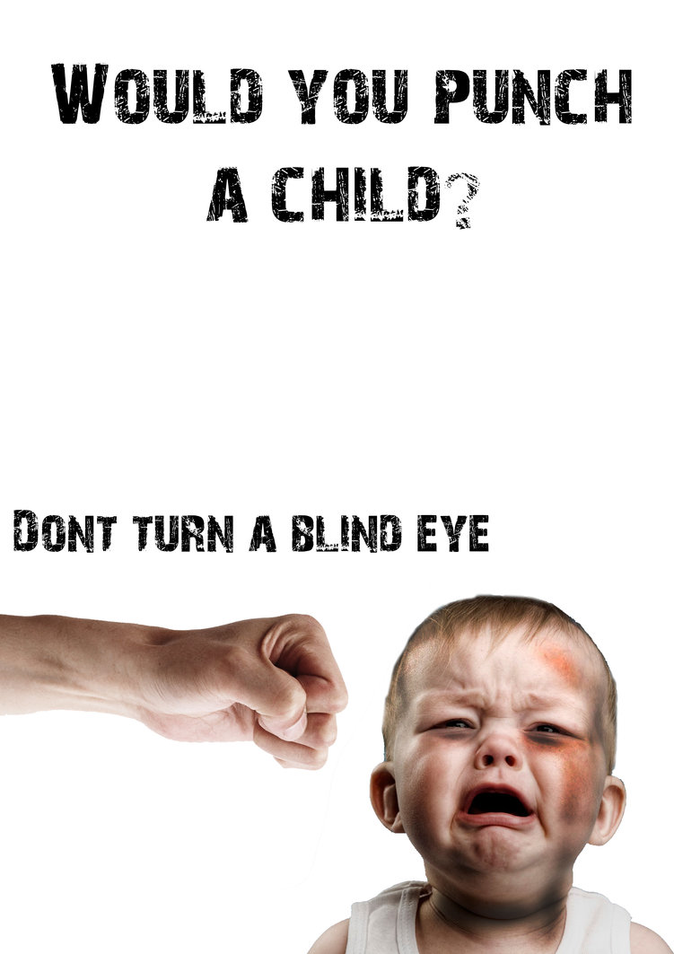

Agencies that help stop Child Abuse:
DHR, AAP, AHA, NCCP
If you see child abuse report it!

